**CSA05: DATABASE MANAGEMENT SYSTEMS-ASSIGNMENT**

**ER Diagram Question: Traffic Flow Management System (TFMS)**

**Entities and Attributes:**

1. **Roads**
   * RoadID (PK)
   * RoadName
   * Length (meters)
   * SpeedLimit (km/h)
2. **Intersections**
   * IntersectionID (PK)
   * IntersectionName
   * Latitude
   * Longitude
3. **Traffic Signals**
   * SignalID (PK)
   * IntersectionID (FK)
   * SignalStatus (Green, Yellow, Red)
   * Timer
4. **Traffic Data**
   * TrafficDataID (PK)
   * RoadID (FK)
   * Timestamp
   * Speed
   * CongestionLevel

**Relationships:**

1. **Roads and Intersections**
   * Each road can connect to multiple intersections, and each intersection can connect to multiple roads.
   * Relationship: Many-to-Many (implemented with an associative entity)
2. **Intersections and Traffic Signals**
   * Each intersection can have multiple traffic signals, but each traffic signal belongs to one intersection.
   * Relationship: One-to-Many
3. **Roads and Traffic Data**]
   * Each road can have multiple traffic data records, but each traffic data record belongs to one road.
   * Relationship: One-to-Many

**Cardinality and Optionality Constraints:**

1. **Roads to Intersections**
   * Many-to-Many (mandatory for both entities)
2. **Intersections to Traffic Signals**
   * One-to-Many (mandatory for intersections, optional for traffic signals)
3. **Roads to Traffic Data**
   * One-to-Many (mandatory for roads, optional for traffic data)

LOGICAL MODEL

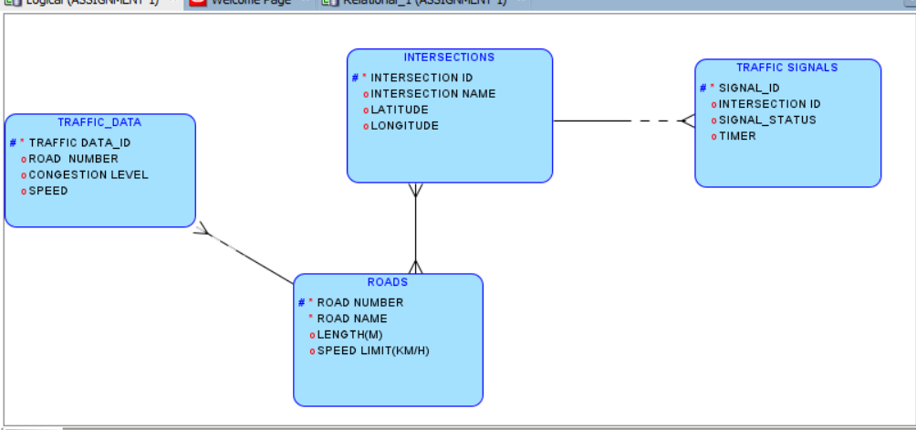

RELATIONAL MODEL

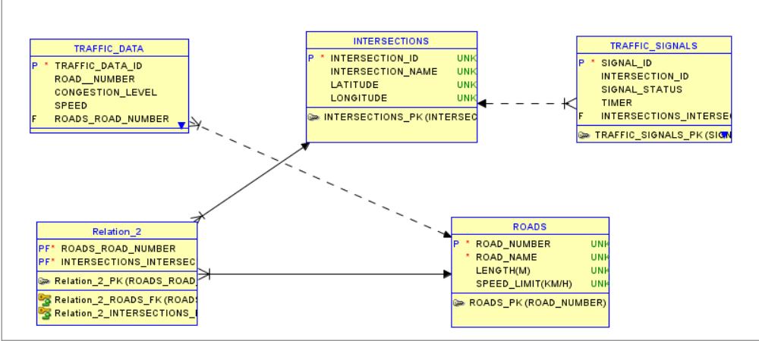

**Justification Document**

**Design Choices:**

1. **Scalability**:
   * **Design Choice**: Use of associative entities for many-to-many relationships (e.g., RoadIntersections).
   * **Reason**: Facilitates the addition of new roads and intersections without major schema changes, ensuring that the system can grow with the city’s infrastructure.
2. **Real-Time Data Processing**:
   * **Design Choice**: Separate Traffic Data entity linked to Roads.
   * **Reason**: Allows efficient storage and retrieval of real-time traffic data, enabling dynamic adjustments to traffic signals and route suggestions.
3. **Efficient Traffic Management**:
   * **Design Choice**: Entities like Traffic Signals and Traffic Data directly linked to Intersections and Roads.
   * **Reason**: Ensures that traffic signals and real-time data are directly connected to the relevant intersections and roads, facilitating timely and location-specific traffic management decisions.

**Normalization Considerations:**

1. **1NF (First Normal Form)**:
   * **Consideration**: Ensuring that all tables have a primary key and that all attributes contain atomic values.
   * **Impact**: Eliminates duplicate records and ensures data integrity at the most basic level.
2. **2NF (Second Normal Form)**:
   * **Consideration**: Eliminating partial dependencies by ensuring that all non-key attributes are fully functionally dependent on the primary key.
   * **Impact**: Prevents redundancy by ensuring that each piece of information is stored in only one place.
3. **3NF (Third Normal Form)**:
   * **Consideration**: Removing transitive dependencies so that non-key attributes do not depend on other non-key attributes.
   * **Impact**: Further reduces redundancy and ensures that data modifications (inserts, updates, deletes) are efficient and error-free.

**How the ER Diagram Supports TFMS Functionalities:**

1. **Route Optimization**:
   * **Support**: The Traffic Data entity stores real-time and historical data, which can be analyzed to suggest optimal routes.
   * **Functionality**: Algorithms can use the stored speed and congestion levels to compute the best routes in real-time.
2. **Traffic Signal Control**:
   * **Support**: The Traffic Signals entity, linked to Intersections, can dynamically adjust signals based on the Traffic Data.
   * **Functionality**: Real-time data allows adaptive control algorithms to adjust signal timings to optimize traffic flow.
3. **Historical Analysis**:
   * **Support**: Historical traffic data stored in the Traffic Data entity.
   * **Functionality**: Enables analysis of traffic patterns over time, aiding in future traffic planning and management.
4. **Intersection Management**:
   * **Support**: Intersections entity manages key points where roads meet, with traffic signals and real-time data linked to these intersections.
   * **Functionality**: Ensures that intersections, critical points for traffic flow, are efficiently managed and monitored.
5. **Road Network Management**:
   * **Support**: Roads entity with attributes like length and speed limit.
   * **Functionality**: Facilitates the management of the road network by providing detailed information on each road, essential for both route optimization and traffic signal control.

By adhering to these design choices and normalization principles, the ER diagram ensures that the Traffic Flow Management System is robust, scalable, and capable of handling real-time data efficiently while minimizing redundancy and maintaining data integrity.